Credit

2140

Assignment

E9 Guessing Game

Errors

What caused the error and how do you overcome the error?

If player puts number above 20 it still works

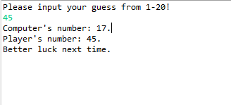

Goingto fix

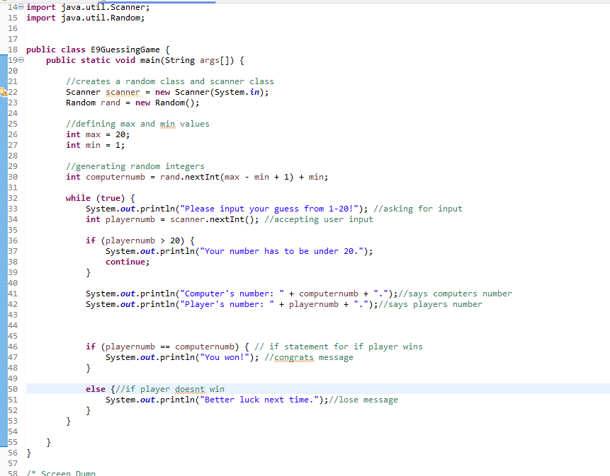added a loop to make it if user puts something higher then 20 it reasks for input

Need to add a loop break

Break added

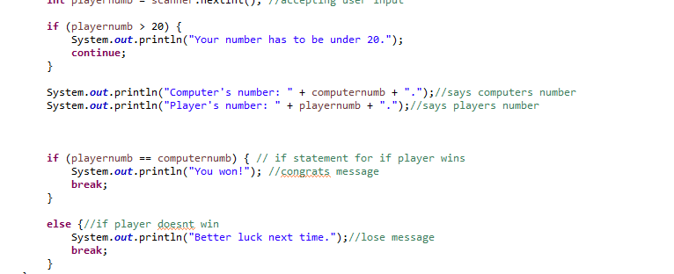

Need to fix comments

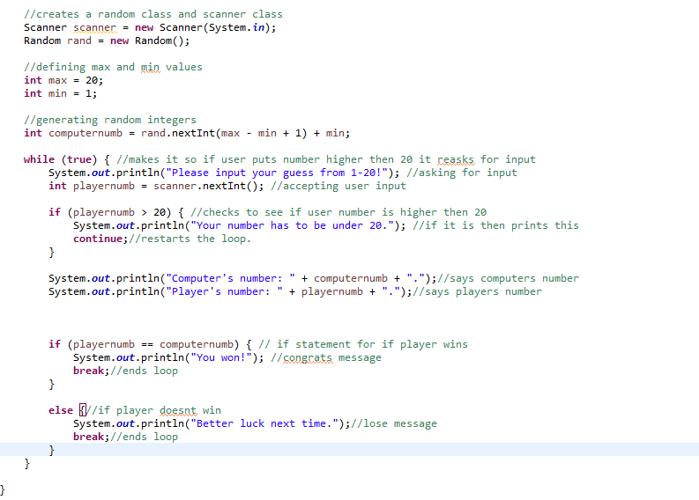final code